**Advanced training of employees of water management organizations: experience of cooperation between KazNARU and RSE "Kazvodkhoz"**

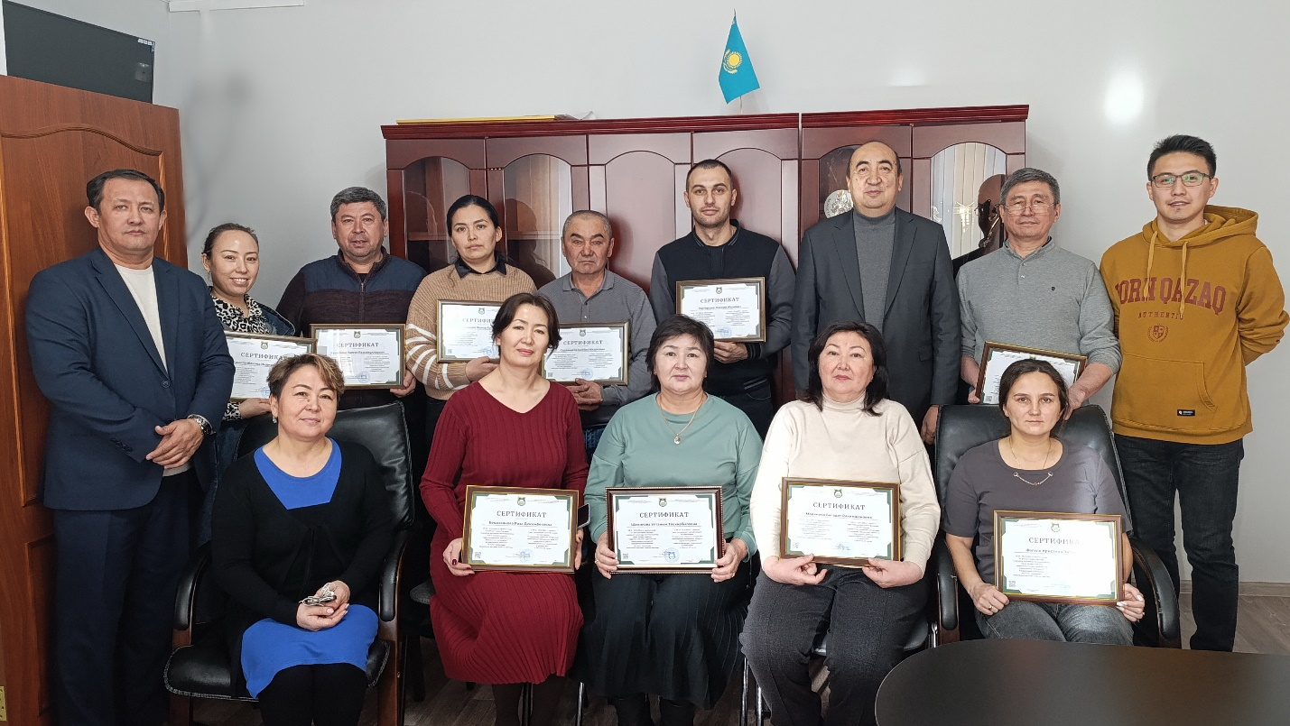 In the context of the implementation of the state program for the development of water resources of the Republic of Kazakhstan and the consistent implementation of the instructions of the Head of State aimed at improving the efficiency of the functioning of the water sector, the issue of training and retraining of personnel is of particular importance. In this regard, the cooperation of higher educational institutions with industrial enterprises is becoming one of the key factors in ensuring high-quality and modern vocational education.

Within the framework of this cooperation, an agreement was signed between the Kazakh National Agrarian Research University (KazNARU) and the Karaganda branch of the Republican State Enterprise on the right of economic management "Kazvodkhoz", providing for joint educational events. In accordance with the terms of the contract, a group of employees of the International Water Center and teachers of the Department of Water Resources and Land Reclamation of KazNARU (Ryabtsev A.D., Ishangaliyev T.S., Auelbek E.K., Murat D.) went to the production site of the branch to conduct field classes with employees of the enterprise.

During the classes, university teachers passed on to the students relevant knowledge and practical skills in the field of water construction, operation of hydraulic structures, water resources management. Theoretical classes were accompanied by practical exercises and problem solving, which allowed students to consolidate the knowledge gained.

As a result of the training, all participants successfully passed the final certification and were awarded certificates confirming the improvement of their qualifications.

An important aspect of the field classes was the direct acquaintance of teachers with the production process at the enterprise. In particular, in a conversation with the employees of the Intumak hydroelectric power plant, the teachers got acquainted with the technological features of production, existing problems. Based on the data obtained, specific recommendations were developed to optimize production processes, improve the reliability and efficiency of equipment operation.

In parallel with the advanced training of existing specialists, the teachers of the department conducted career guidance work. The purpose of this event was to inform about the areas of training implemented in KazNARU, and about the prospects for employment in the industry, familiarization with modern technologies and equipment used in the educational process. Thus, field classes have become not only a platform for advanced training, but also an effective tool for attracting talented young people to the university.

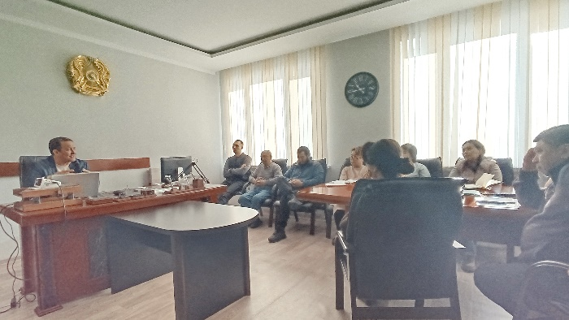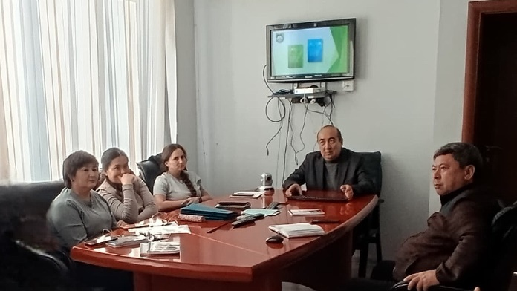

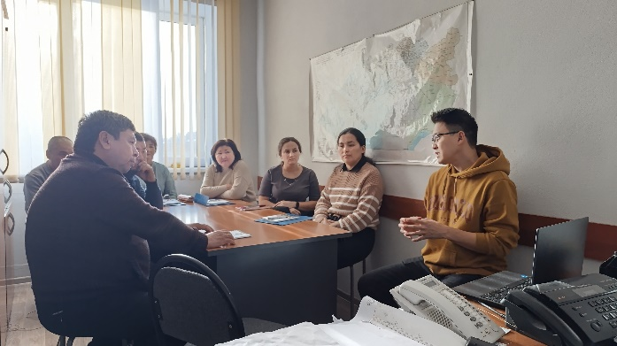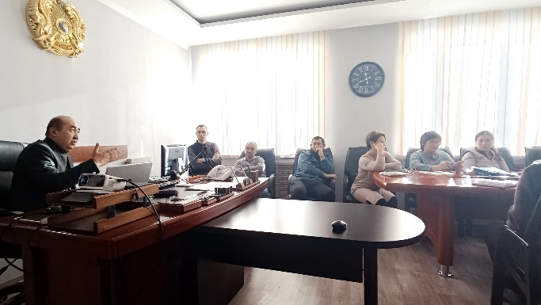

The result of all the activities carried out was not only the improvement of the professional level of the employees of the Karaganda branch of the RSE "Kazvodkhoz", but also the strengthening of cooperation between the university and the manufacturing enterprise. This experience indicates the need for further development of such forms of interaction aimed at creating an effective system of personnel training for the water sector of the Republic of Kazakhstan.

Ishangaliyev T.S. - аssociate рrofessor

Auelbek E.K. - senior lecturer